WT-504G G.SHDSL Router

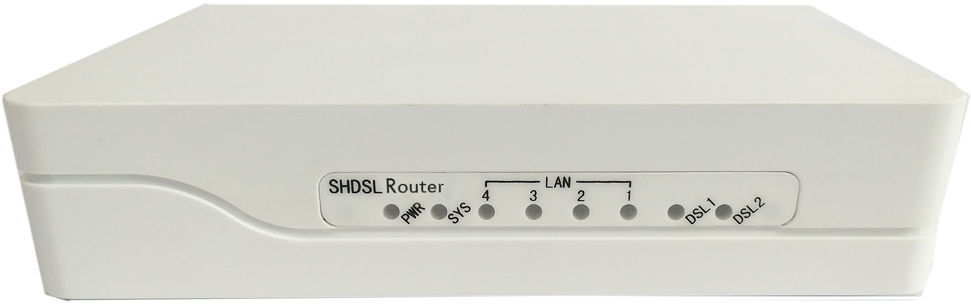

Description

The WT-504G, a SHDSL (Single-pair High-bit-rate Digital Subscriber Line) Router, provides a broadband transmission with bandwidth up to 5.696Mbps (15Mbps for PAM128 ) over a single pair of copper wires for LAN connection between two local area networks. WT-504G provides a console port for users to configure the settings and to monitor the DSL connection status.

WT-504G conforms to ITU-T G.991.2, the GSHDSL requirements. Each WT-504G can be configured as either STU-C for the central side or STU-R for the remote side. 1 / 2 pair of WT-504G offers a cost effective symmetrical broadband solution for bandwidth-hungry applications such as LAN-to-LAN connection, Internet
Features

- ITU G.991.2 Annex A, Annex B ,Annex F, Annex G
- Symmetrical downstream and upstream data rates from 192Kbps to 15Mbps
- Support ATM/EFM over SHDSL
- Auto or Fixed DSL rate operation
- Auto-Negotiation for 10/100 Base-T
- Auto-MDIX for Auto Ethernet Tx/Rx Swap
- SNMP management with SNMPv1 / SNMPv2 /SNMPv3 agent and MIB II
- Support 802.1q with 4094 VLAN
- Support DHCP server
- Support ping tool
- Support Bridge, Routing and NAT via setting
- Web ,Telnet supported
- Getting enhancements and new features via firmware upgrade

Specification

G.SHDSL Specification
- Fully compliant with standards of ETSI (SHDSL, SHDSL.bis), ITU (G.SHDSL, G.SHDSL.bis, g.998.2/g.bond) and IEEE (EFM)
- Line Code: TC-PAM 16/32/64/128
- M-pair mode for 1/2 pairs
- ITU G.991.2 Annex A ,B
- STU-C/STU-R mode selectable
- Impedance: 135 ohm
- SNR /Attenuation Value calculation
Physical interfaces
- 4 ports RJ45 for 10/100Mbps Ethernet LAN connection
- RJ-45 ports for G.SHDSL connection
- 1 console port for local configuration and management
ATM Protocol
- ATM adaptation layer type 5 (AAL5)
- VC multiplexing and LLC encapsulation
- Multi-protocol over AAL5 (RFC 1483 bridged PDU)
- Support 5 PVCs
Bridging
- IEEE 802.1D transparent learning bridge
- Up to 1K MAC learning addresses
Routing Capability
- Support IP/TCP/UDP/ARP/ICMP protocols
- IP routing with static routing and RIPv1/RIPv2 (RFC1058/2453)
Configuration
- Local console
- Telnet access
- Web-based GUI

Network Management
- Web-based GUI for express setup, configuration and management
- CLI interface for local console and Telnet access
- Password protected management
- SNMP management with SNMPv1/v2c/v3
- Software upgrade via HTTP

Hardware

Power Supply | Adaptor 100~240V AC, 50/60Hz : plastic  AC 90~260Vac(47~63Hz), DC -36 ~ -72 Vdc. AC+DC seletable : Metal
LAN Port | RJ45 x 4
WAN Port | RJ45 x 1
Console Port | RJ45x 1
Operating temperature | 0° to 45°C
Storage temperature | -10° to 70°C
Housing | plastic / Metal
Dimension | 215 mm x 120mm x 44 mm (L x W x H) : plastic  234.4mm x 155.5mm x 44.2 mm : Metal

